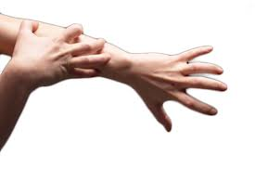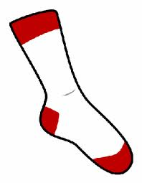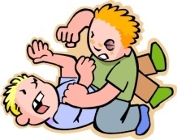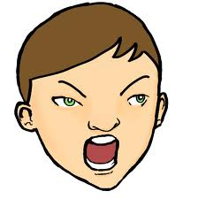

Am i..?

Worried?

Shouting?

Hurting people?

Frowning?

Crying?

Chewing things?

Scratching my arm?

Follow the pages of this book to help you feel good again!

Mirror

Take 5 nice slow deep breaths

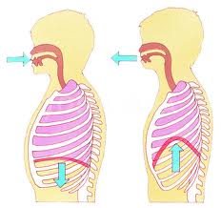

3

5

4

2

1

Count backwards from 10 slowly using caterpillar counting



1 caterpillar

2 caterpillar

3 caterpillar

4 caterpillar

5 caterpillar

6 caterpillar

7 caterpillar

8 caterpillar

9 caterpillar

10 caterpillar



1. Go all floppy like a jelly
2. Tense all of your muscles like a fighter

What were your answers? Now turn over the page…

Is my heart beating more slowly, feel it.

Does my face look relaxed with no wrinkly bits, check in the mirror?

Am I breathing slowly and calmly?

Am I ready to use a calm voice to talk through my worry?



Yes!

I might need some more time.

Start at the first page and have another go!

Well done!

You calmed yourself down.

If I need to talk I can;

1. Find my Teacher
2. Wait until my Teacher is ready to listen
3. Tell my Teacher calmly what the problem is
4. My Teacher will try to help me sort it out

No

Our calm down book